|  |  |  |  |  |  |
| --- | --- | --- | --- | --- | --- |
| **Test Name** | | Change Password | | | |
| **Use Case Tested:** | | Use Case 9 – Manage Worker | | | |
| **Test Description:** | | User searches for login details  User selects specific login  User changes password | | | |
| **Pre-conditions** | | Login must exist in the system | | | |
| **Post-conditions** | | The database is successfully updated with the new data for the Login. | | | |
| **Notes:** | |  | | | |
| **Result (Pass/Fail/Warning/Incomplete)** | |  | | | |
|  | **TEST STEP** | | **EXPECTED TEST RESULTS** | P | F |
|  | User selects “Search Users” from the menu bar | | Search Users form appears |  |  |
|  | User selects the labsupervisor account to change the password for by clicking the corresponding “Change Password” button | | Change password dialogue appears |  |  |
|  | User Enters an invalid password | | Input show an error |  |  |
|  | User submits | | A warning box appears because there are errors with the form, no submission |  |  |

|  |  |  |  |  |  |
| --- | --- | --- | --- | --- | --- |
| **Test Data Table** | | | | | |
|  | **1** | **2** | **3** | **4** | **5** |
| Test – 1 | 2short |  |  |  |  |
| Test – |  |  |  |  |  |
| Test – |  |  |  |  |  |
|  |  |  |  |  |  |

User clicks on “Search User”

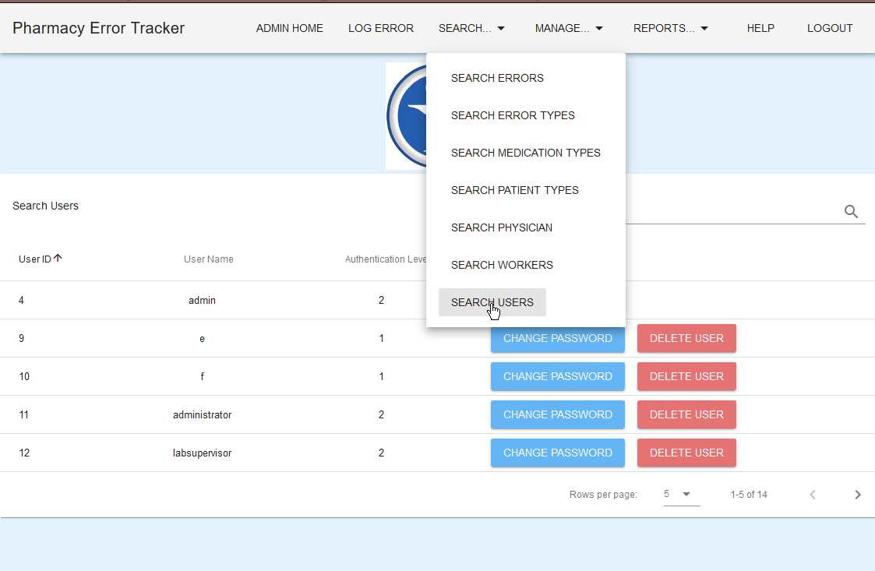

Changing the password for lab supervisor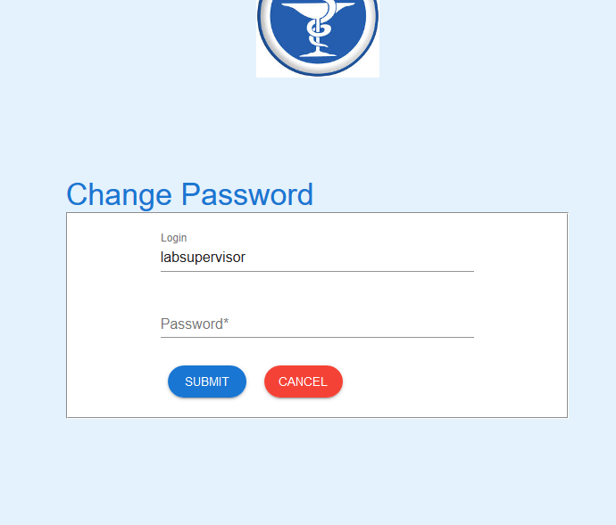

Password set to “2short”

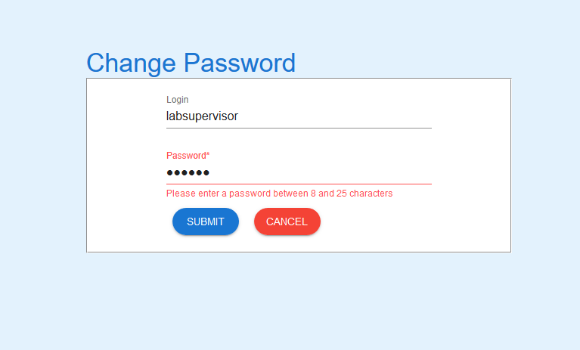

Failure message

